
SCHOOL OF COMPUTING AND INFORMATICS
SEMESTER 2/ YEAR 2

CCS2253 Parallel and Distributed Databases
Group Project

Names | Student ID
Myat Min Khant | AIU23102103
Maria Iqbal | AIU23102118
Mohamed Abdullahi Ali | AIU22102342

Table of Contents
(1) Translate the the E-R Model to relational model. 2
1. Shoppo DB Schema 2
2. LaLaZa DB Schema 2
3. NeverReach Express DB Schema 3
(2)Identify the database integration issues. 4
(3) Design a global conceptual schema relational model as a combination of the three databases. 5

(1) Translate the the E-R Model to relational model.

1. Shoppo DB Schema
Customers (customer_id PK, full_name, email, phone_number, home_address)
Discounts (discount_id PK, discount_amount, discount_percentage, product_id FK, start_date, end_date)
Inventory_Stocks (product_id FK, warehouse_id FK, quantity_available, reorder_threshold)
OrderDetails (order_detail_id PK, order_id FK, product_id FK, quantity, price_per_unit)
Orders (order_id PK, customer_id FK, order_date, total_amount, total_weight, shipping_cost)
Payments (payment_id PK, order_id FK, payment_method, paid_date, total_paid)
Products (product_id PK, name, description, weight_kg, product_category, base_price, discount_id FK)
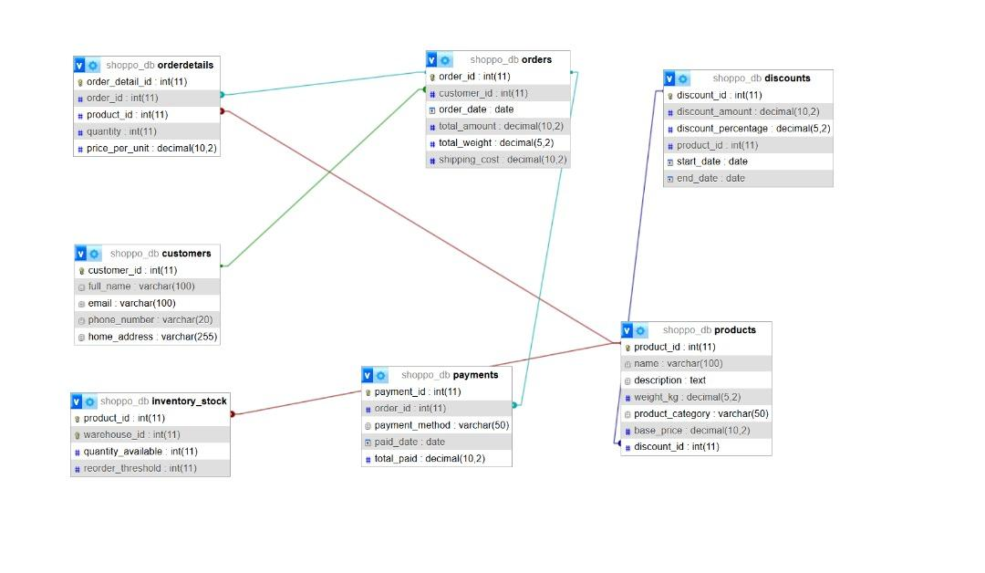
Figure 1: E-R Model for Shoppo

2. LaLaZa DB Schema
Users (user_id PK, name, email_address, mobile, address)
Address (user_id FK, address_id PK, address, additional_info)
Items (item_id PK, title, summary, weight, category_id FK, unit_price, quantity_available, shipping_fee)
Categories (category_id PK, category_title)
Purchases (purchase_id PK, user_id FK, purchase_timestamp, subtotal, delivery_charge, promo_code)
Cart (cart_id, purchase_id, item_id, qty)
Transactions (txn_id, purchase_ref, payment_method, txn_date, amount)
PromoCodes(promo_code , promo_id PK, minimum_purchase, start_date, end_date, redeemed)
UserPromotions(user_id FK, promo_id FK , promo_code, redeemed)
Promotions (promo_id PK , promo_name, discount_type, discount_value)

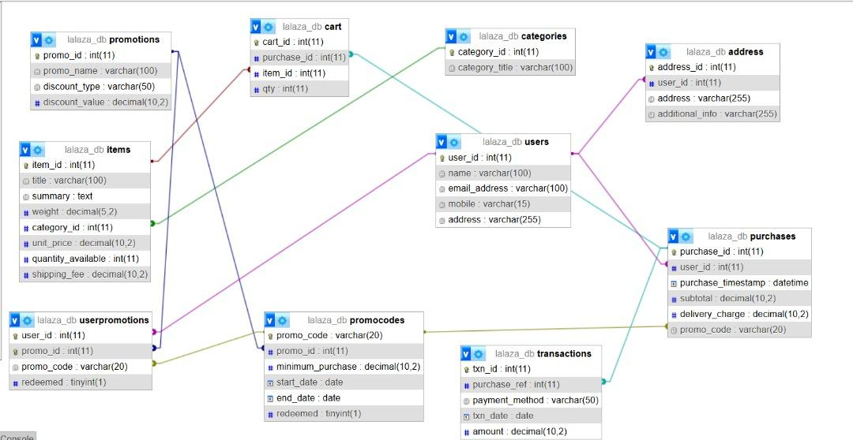
Figure 2: E-R Model for LalaZa

3. NeverReach Express DB Schema
Warehouses (warehouse_id PK, location, capacity, manager_id FK)
Employees (employee_id PK, name, position, email, phone_number)
Shipments (shipment_id PK, origin_warehouse_id FK, destination_warehouse_id FK, address, departure_time,
arrival_time, status)
Packages (package_id PK, shipment_id FK, order_id FK, weight, dimensions, fragile_flag)
Vehicles (vehicle_id PK, license_plate, type, capacity, assigned_driver_id FK)
Delivery_Tracking(tracking_id PK, package_id FK, status_update_time, location, status_note)
Delivery_Assignments(assignment_id PK, driver_id FK, package_id FK, assigned_date, delivery_status)
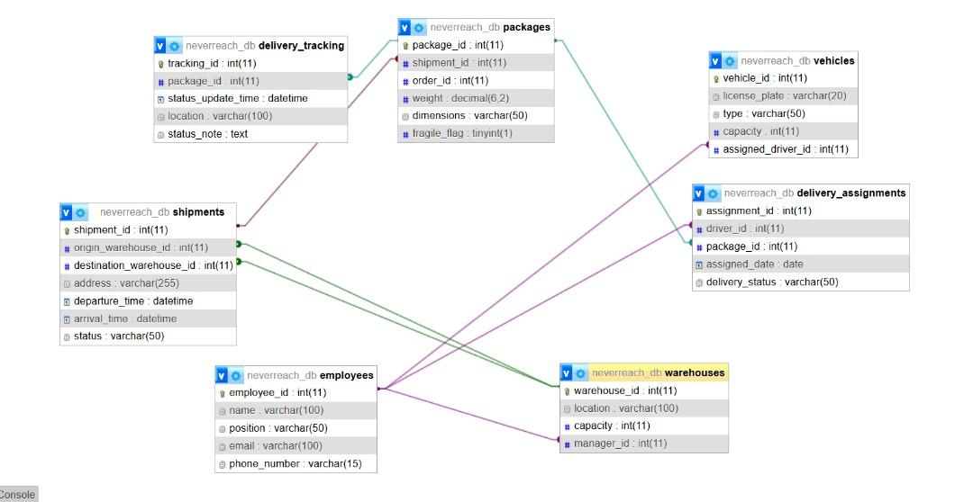
Figure 3: E-R Model for NeverReach

(2) Identify the database integration issues.
Structural heterogeneity
- Type Conflict
- Example: In Shoppo DB, the category is an attribute in the Product table and in LalaZa DB, the category is a separate table.
- Example: In Shoppo, the customer’s address is stored as an attribute inside the customers table whereas in LaLaZa, the address is modeled as a separate table (addresses) linked to users.
- Dependency Conflicts
- Example: In Shoppo, discounts are stored in a single Discounts table with no complex linking. In LaLaZa, the logic is more complex: Promotions define the discount, PromoCodes define usage, UserPromotions link specific users to codes.
- Key Conflicts
- Example: ShoppoDB uses customer_id and LaLaZaDB uses user_id
- Example - Shoppo uses product_id, while LaLaZa uses item_id.
- Example - Shoppo uses order_id while LaLaZa uses purchase_id.

Semantic heterogeneity
- Synonyms, Homonyms, Hypernyms
- Synonyms Issue: Different names for the same or overlapping concepts.
Solution:
- Customers (Shoppo) vs. Users (LaLaZa) → unified as Customers
- Products (Shoppo) vs. Items (LaLaZa) → unified as Products
- Orders (Shoppo) vs. Purchases (LaLaZa) → unified as Orders
- Payments (Shoppo) vs Transaction (LaLaZa) → unified as Payments

- Different Ontology
Examples:
- NeverReach models logistics (Shipments, Packages, Delivery_Tracking).
- Shoppo and LaLaZa do not.
Solution: Introduced logistics tables (Shipments, Packages, etc.) in GCS and linked them to Orders.

(3) Design a global conceptual schema relational model as a combination of the three databases.
Customers (customer_id, customer_name, email, phone_number, home_address)
Addresses (address_id, customer_id, address, additional_info)
Orders (order_id, customer_id, order_date, total_amount, shipping_cost, promo_code (FK))
OrderDetails(order_detail_id, order_id, product_id, quantity, unit_price)
Payments (payment_i, order_id, payment_method, payment_date, amount_paid)
Products (product_id, product_name, description, weight, category_id, base_price, discount_id, shipping_fee)
Categories (category_id, category_title)
Discounts (discount_id, discount_name, discount_type, discount_value, start_date, end_date, is_active)
PromoCodes(promo_code, discount_id , minimum_purchase, start_date, end_date, redeemed)
Inventory_Stock(inventory_id, product_id, warehouse_id , quantity_available, restock_date, minimum_stock_level)
Warehouses (warehouse_id, location, capacity, manager_id )
Employees (employee_id, name, position, email, phone_number)
Shipments (shipment_id, origin_warehouse_id, destination_warehouse_id , delivery_address, departure_time, arrival_time, status)
Packages (package_id, shipment_id, order_id, weight, dimensions, fragile_flag)
Delivery_Tracking(tracking_id, package_id, status_update_time, location, status_note)
Delivery_Assignments(assignment_id, driver_id, package_id , assigned_date, delivery_status)
Vehicles (vehicle_id, license_plate, type, capacity, assigned_driver_id)
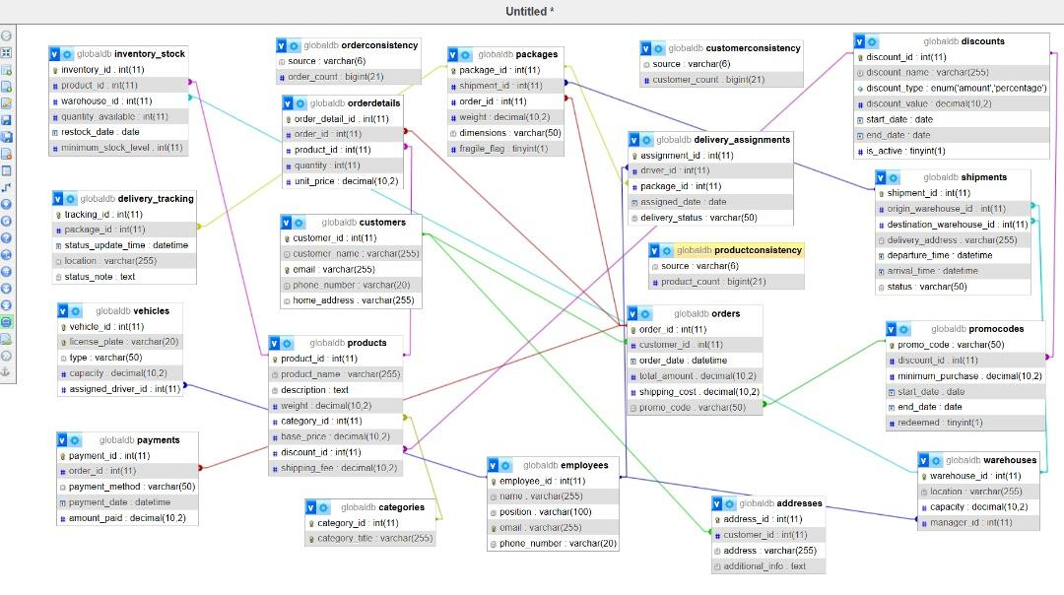
Figure 4: E-R Model for Global Schema

